**Vue cli**

Install vue cli globally --- npm install –g @vue/cli

Attribute binding --- v-bind:attribute(href)/:href=”url”

<img :src="book.img" :alt="book.title" >

Conditional block --- v-if=’true’

v-else

Looping array

v-for='book of filterFavBooks'

Event binding --- @click/v-on:click

@click='toggleFavourite(book)'

Dynamic classes

:class="{fav: book.isFav}"

Computed properties --- is a way to define data property inside our component that depends on the data that present in the component

computed: {

        filterFavBooks() {

            return this.books.filter(book => book.isFav)

        }

    }

<div class="bookLists">

            <ul>

                <li class="books" v-for='book of filterFavBooks' :class="{fav: book.isFav}" @click='toggleFavourite(book)'>

                    <img :src="book.img" :alt="book.title" >

                    <h3>{{book.title}}</h3>

                </li>

            </ul>

        </div>

Template refs

<div class="row">

    <input type="text" ref="name" />

    <button class="btn-primary" @click="clickHandle()">Click</button>

  </div>

clickHandle() {

      this.$refs.name.classList.add("active");

      this.$refs.name.focus();

    }

Multiple components

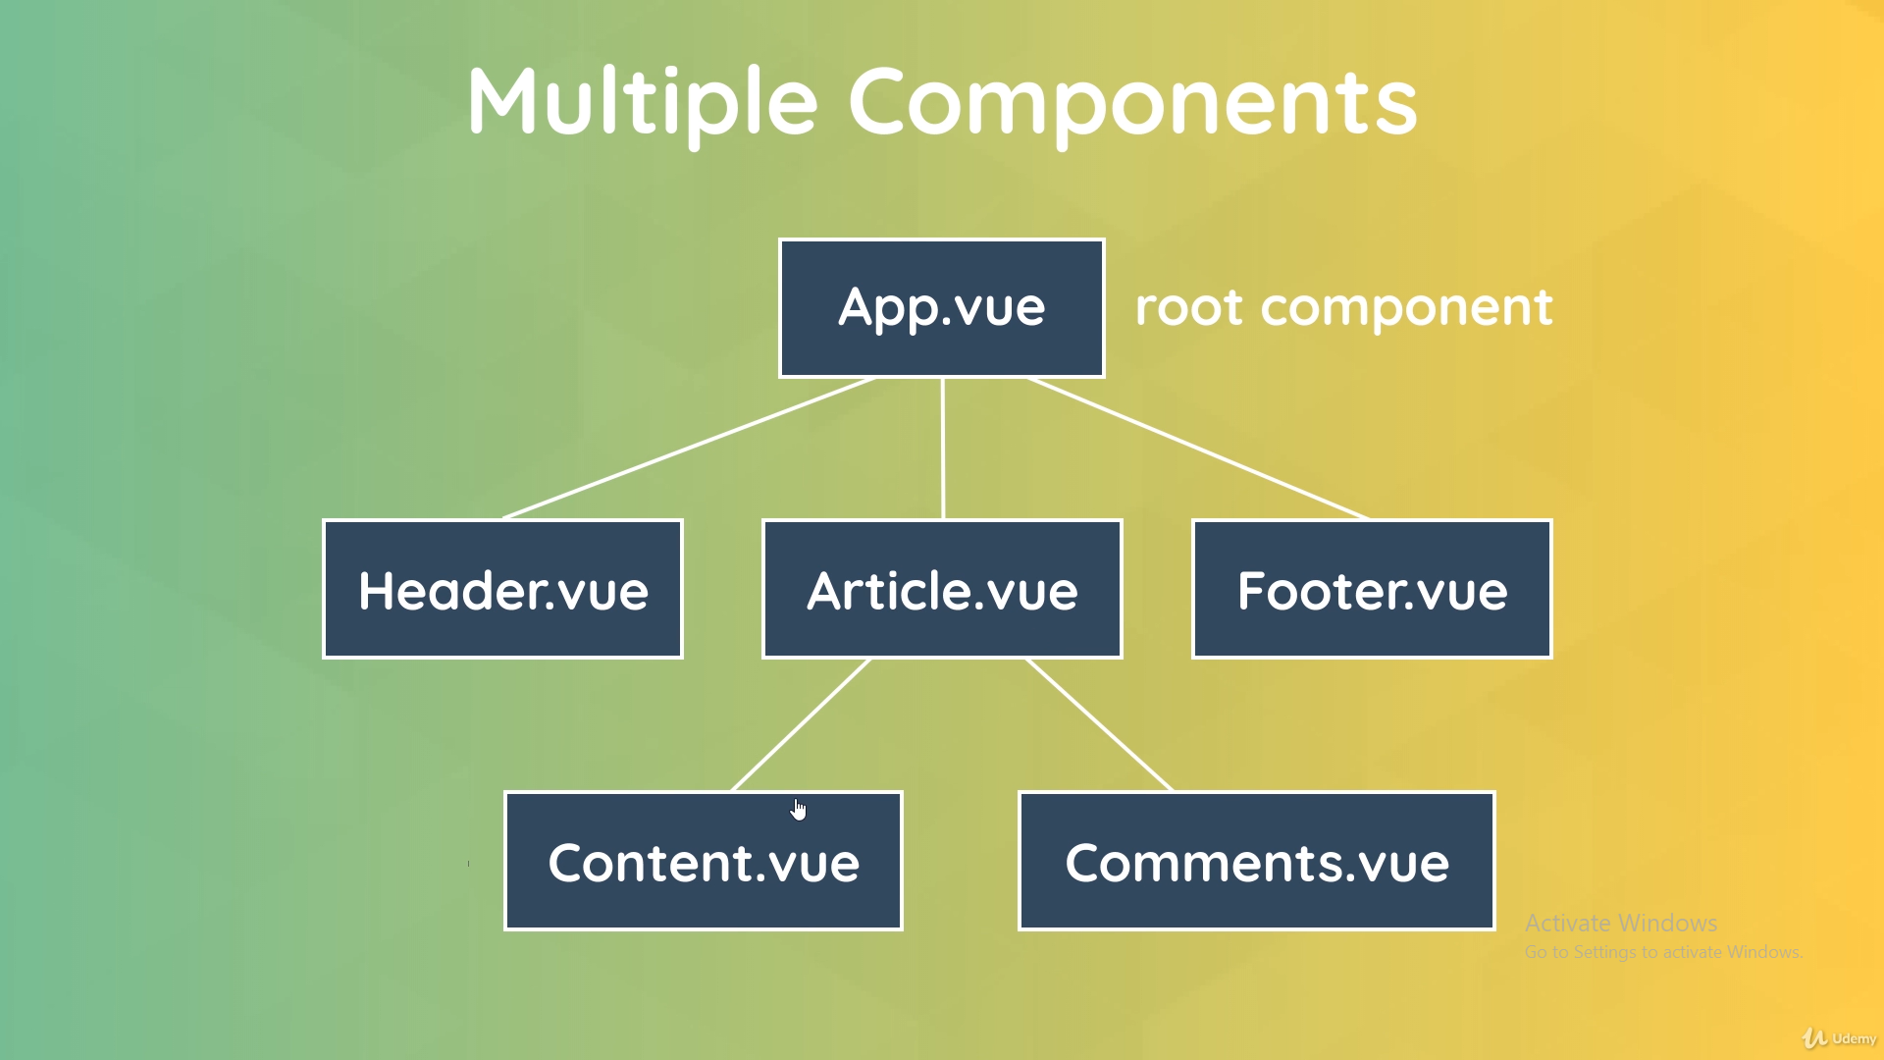

Terminology

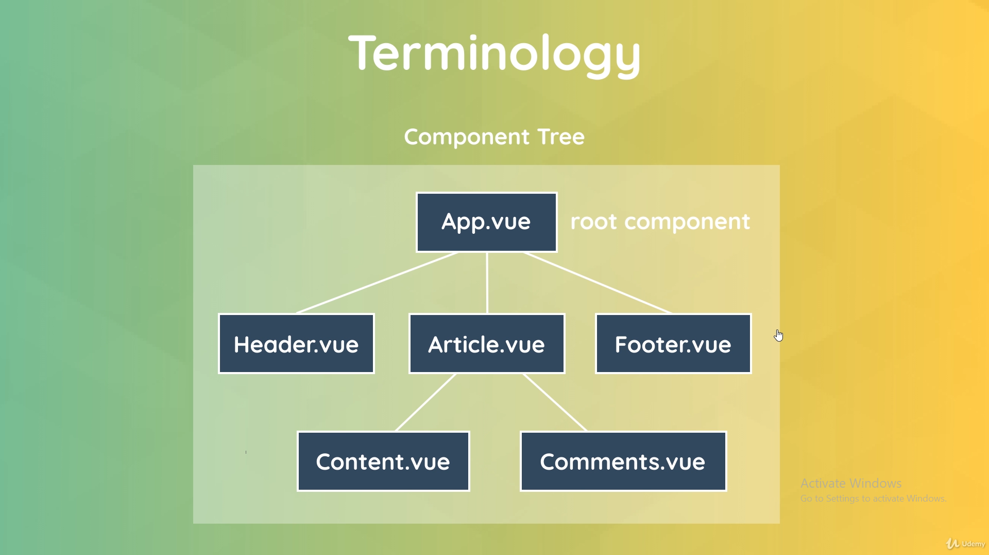

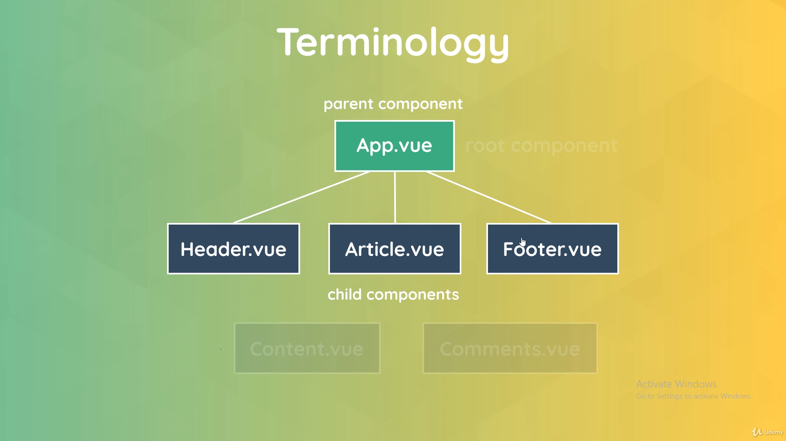

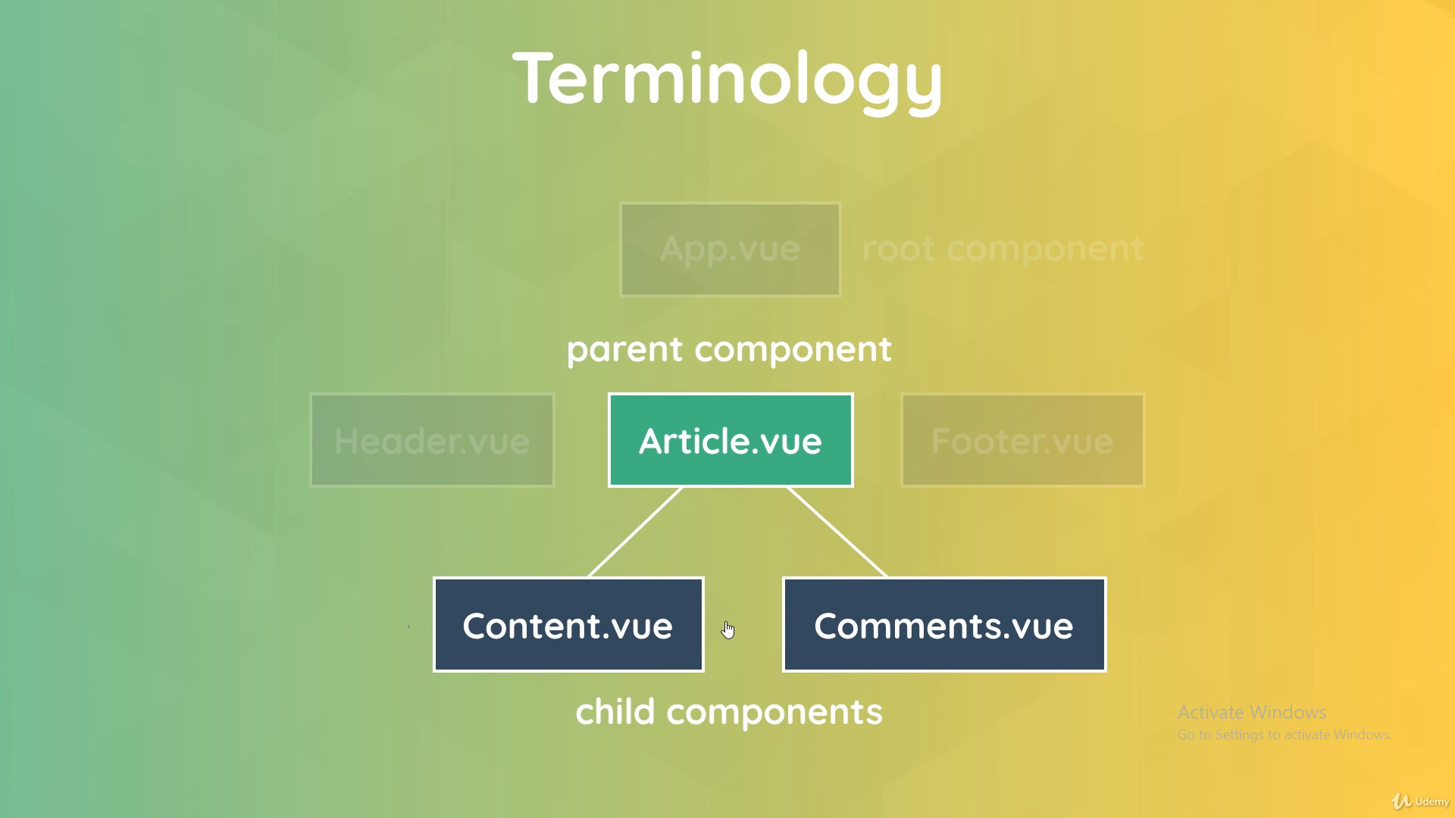

Creating and registering component

Create [filename].vue file and import it in the component where we are going to use

import Modal from "./components/Modal";

components: { Modal }  
<Modal />

**How scoped styles are applied** --- It will generate random unique data attribute for scoped styles like .modal[data-v-701ac82d] in the below image

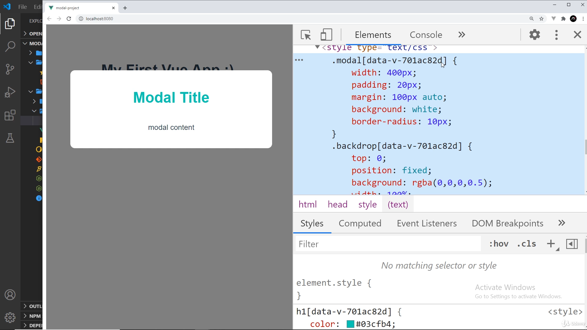

Passing data with props

1. Pass string value to modal -
2. <Modal header="Signup for Giveaway!" text="Grab your swag for half price" />
3. Declare props array in the component and register the string values on in
4. export default {
5. props: ["header", "text"],
6. };
7. bind the props array value in the component
8. <h1>{{ header }}</h1>
9. <p>{{ text }}</p>

Passing value with bind property

1. Create data object that returns the values
2. data() {
3. return {
4. header: "Signup for Giveaway!",
5. text: 'Grab your swag for half price',
6. sale: 'sale'
7. };
8. }
9. Bind the property to the component tag
10. <Modal :header="header" :text="text" :theme="sale" />
11. Set props array with the data binding attribute as key
12. export default {
13. props: ["header", "text", "theme"],
14. };
15. Use it in the component
16. <div class="modal" :class="{sale: theme === 'sale'}">
17. <h1>{{ header }}</h1>
18. <p>{{ text }}</p>
19. </div>